**Weather Trends**

* Is your city hotter or cooler on average compared to the global average? Has the difference been consistent over time?

1. My city (Riyadh) average temperature is hotter than the average global temperature, yes, it’s relatively consistent.

* “How do the changes in your city’s temperatures over time compare to the changes in the global average?”

1. My city little bit fluctuating average temperatures than the global average temperatures.

* What does the overall trend look like? Is the world getting hotter or cooler? Has the trend been consistent over the last few hundred years?

A) The overall trend that’s the world gets hotter. Yes, it is.

**Outlines:**

* Extract the data from database in Udacity website by using SQL query.

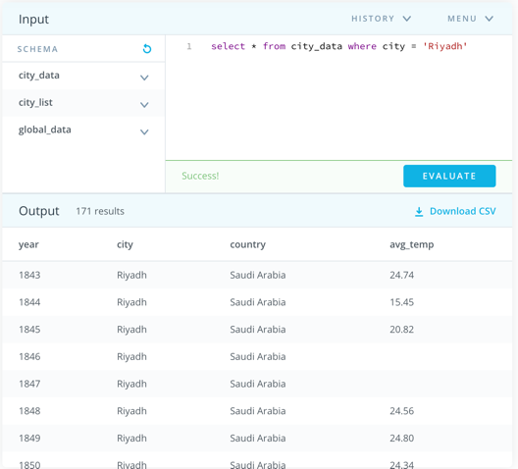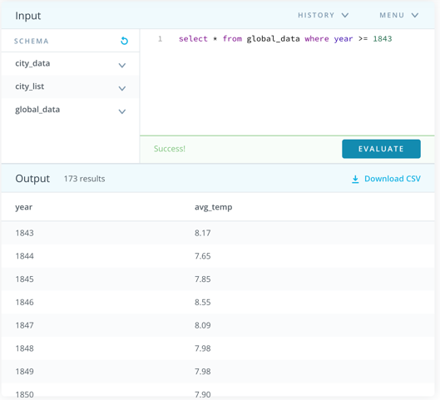

* Using excel
* Starting to calculate after first 7 days and continue to the end(7-dayMA).
* I had to use c Line Chart to visualize the trends.